Community Monitoring and Social Accountability of Health Services
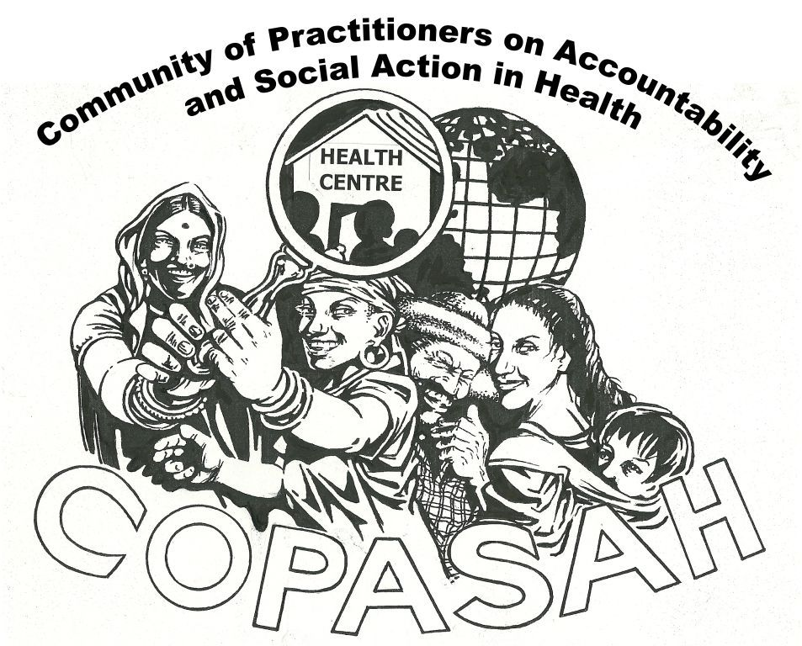
Training Programme for South Asia
21st – 25th September 2013, Delhi
Organized by: COPASAH
Concept Note
Global Steering Committee:

- Abhay Shukla, Support for Advocacy and Training to Health Initiatives (SATHI), India.
- Abhijit Das: Centre for Health and Social Justice
- Ariel Frisancho Arroyo, Care, Peru
- Rene Loewenson, Training and Research Support Centre (TARSC), Zimbabwe
- Renu Khanna, Founder Member, SAHAJ Society for Health Alternatives, Baroda
- Robinah Kaitiritimba, National Health Users/Consumers Organization (UNHCO), Uganda
- Walter Flores, Centro de Estudios para la Equidad y Gobernanza en los Sistemas de Salud-CEGSS (Center for the Study of Equity and Governance in Health Systems) (CEGSS), Guatemala.
- Vinay Viswanatha, Accountability and Monitoring in Health Initiative (AMHI), USA.

Global Secretariat

CENTRO DE ESTUDIOS PARA LA EQUIDAD Y GOBERNANZA DE LOS SISTEMAS DE SALUD (CEGSS
11 Calle 0-48 Ed. Diamond
Oficinna 504, Zona 10
Gautemala City, Gautemala

Regional Secretariat

CENTRE FOR HEALTH AND SOCIAL JUSTICE (CHSJ)
Basement of Young Women’s Hostel No.2
Avenue 21, G Block
New Delhi-110017

Global Secretariat:

Regional Secretariat :
Context: Community of Practitioners on Accountability and Social Action in Health (COPASAH) is a global network of practitioners with a common interest and passion for the field of community monitoring for accountability in health. COPASAH was set up by a group of practitioners who had come together for a meeting to share experiences at Johannesburg in July 2011 and currently has a steering committee of 8 members from Asia, Africa and Latin America. COPASAH places a strong emphasis on the role of civil society to not only promote access to equitable, quality and accountable health services, but also to deepen democracy and strengthen citizens’ rights and entitlements.
Community monitoring is a bottom up approach sustained by participatory processes. Through social mobilisation and community generated and owned data, results are used to demand concrete actions to bring about changes in service improvements and equitable distribution of resources. Hence, community-based monitoring is a key strategy both for accountability and increasing citizens’ participation. Since community monitoring is carried out within and by socially excluded population, it adds legitimacy to equity concerns and to specific demands for more responsive and people centred health systems. Evidence of the increasing importance of community monitoring has been seen at the local, regional, national and global level. Community monitoring is used to increase the quality and accountability of health services, and enables the community to play a larger role in not only evaluating the services provided, but also to hold health care providers accountable. Increasingly such community based interventions are also being seen as a key element of deepening the participation of marginalised communities into the democratic governance process, and are becoming part of formal development policies and programmes
With a view to understanding various approaches used by a range of organisations and activists, COPASAH will conduct a five days training workshop on strengthening the capacities of civil society organisations from the South Asian region on community monitoring.
The primary aims and objectives of this five days training workshop are:
- To increase knowledge of social and political determinants of health, health rights, entitlements and accountability.
- To increase knowledge of various community monitoring/ social accountability methods which have been applied in the region, including the role for civil society organisations
- To develop skills in applying social accountability methods
Resource Persons – The training is being designed collaboratively by the COPASAH steering committee which includes experts in Community Monitoring from Asia, Africa and Latin America. The trainers will include Ms Jashodhara Dasgupta (SAHAYOG), Ms Renu Khanna (SAHAJ), Dr Abhay Shukla (SATHI), Dr Rakhal Gaitonde (SOCHARA) and Dr Abhijit Das (CHSJ).
Participants and Application process – This residential training programme is open only to members of COPASAH. It is meant for individuals who are currently associated with programmes which include a social accountability/ community monitoring component, or are working on rights based approaches to health. The participants are expected to be able to understand written English and spoken English, fluency is not expected. Additional language support will be available in Hindi/Urdu and Bengali. Participants will be identified on the basis of an application form (attached) which all applicants will need to fill. The completed form has to be sent by 10th August to bharti@chsj.org . Intending participants who are not members of COPASAH are requested to fill their membership forms online at http://www.copasah.net/membership-form.html
Registration and Fees – A registration fee of Rs 500 or USD 10 will be applicable for all participants. A graded scholarship/ fee structure is available for other participants.
Participants from indigenous/ local / community based organisation can request for full scholarship for their travel/ accommodation/ course fees. Travel scholarship will ordinarily be for AC 3 tier rail fare. A limited number of economy airfare travel scholarships are available for non-India based participants.
Participants from smaller provincial level organisations can request for a fee waiver and/or a travel scholarship.
Participants for larger provincial/ national organisations receiving significant proportion of income from grants can request for a waiver of the course fees. They are expected to meet their travel costs.
Participants from large national organisations / INGOs/ Organisations receiving grants from bilateral and multi-laterals will have to pay a subsidised course fee of 8000 INR / 150 USD. They are expected to meet their travel costs.
Invitation to participate – Selected participants will be informed by the 20th of August. Decisions regarding selection and scholarship will be taken by the Steering Committee and shall be considered final. A total of 30 participants will be invited.
Venue: Delhi
Important dates:
Please complete and submit the application by August 10, 2013.
Notification to successful applicants will be sent by August 20, 2013.
Workshop Dates: September 21 to 25, 2013 (5 days).
For further details you can contact Dr. Bharti Prabhakar on email: bharti@chsj.org;
Tel: +91- 8800729114/ 011 26511425/26535203

