COPASAH
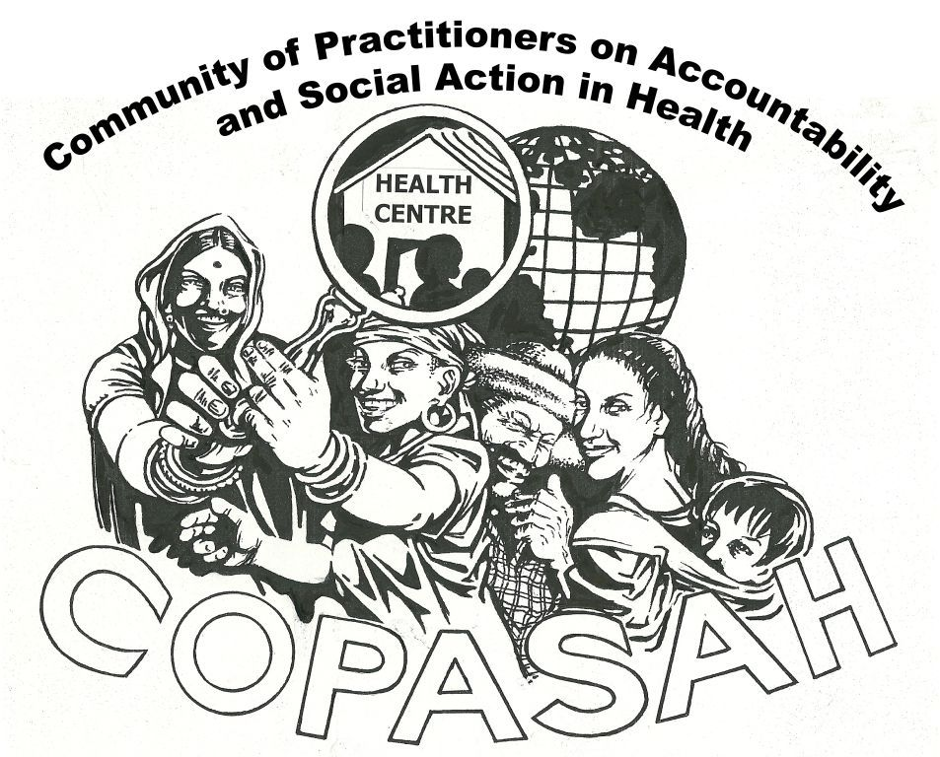

Community of Practitioners on Accountability and Social Action in Health

Are you involved in community monitoring? Or in action and advocacy for accountability for health of the poor and marginalised? Then, you will want to join COPASAH.

COPASAH is a community of practitioners who share an interest in community monitoring for accountability in health. COPASAH members exchange experiences, lessons learnt and share resources. They engage in the production and dissemination of conceptual, methodological and practical material and contribute to strengthening the field. COPASAH encourages networking and peer- learning among member organizations.

Join COPASAH.....
Membership Form

Nature of Membership – Individual / Organisational

Name of the Organisation / Individual

Name and Designation of Contact Person in case of Organisation

Contact Address

Email–

Website
Nature of work related to Accountability and Social Action in Health (Please tick all that apply)
- Community mobilization
- Community based monitoring
- Community based advocacy
- Training and technical support
- Research and documentation
- Others – Specify

Geographical region of work - Latin- Central America/ Africa / Eastern Europe / Asia / Other ( specify)

Geographical extent or scale of work – International/ Regional/ National/ Sub-national/ Community level

Nature of Work - Briefly tell us about your work (country, province, district and community level activities that are undertaken by your organisation). If you are involved in training or technical support or research please tell us about the activities that you are involved in?

Your Approach - How do you promote the concept of ‘accountability’ through your work either at the community level or as a support or resource organisation?

Results and lessons learned- What have been some of the results or achievements of your work? What have been some of lessons that you have learnt in this process?.

Expectations Why do you want to join COPASAH?

What would you like to share with COPASAH (please tick all that apply)
- Reports, results and other descriptions of your work
- Manuals and materials related to your work
- Regular updates about your work through COPASAH listserv or blog
- Contribute to newsletter or discussion group
- Provide information and support to other members on request
- Other (please specify)

Where did you learn about COPASAH?

Anything else you would like to tell us about your work on Accountability and Social Action in Health?

Please send us additional information about your work
- Reports of your work
- Website or any other online information about your work

Please send your filled in Membership form to: copasahnet@gmail.com

We will inform you when your membership has been accepted
All members’ names will be automatically added to the COPASAH listserv.

Members of the Steering Committee
- Abhay Shukla, SATHI, India
- Abhijit Das, CHSJ, India
- Ariel Frisancho Arroyo, CARE, Peru
- Barbara Kaim, TARSC, Zimbabwe
- Renu Khanna, SAHAJ, India
- Robinah Kaitiritimba, UNHCO, Uganda
- Vinay Vishwanath, AMHI-OSF, USA
- Walter Flores, CEGSS, Guatemala

Coordinating Offices:
- CEGSS, Guatemala – Global Secretariat
- UNHCO, Uganda – for Africa
- CHSJ, India – for Asia

To learn more about COPASAH, please visit: www.copasah.net

