COMMUNITY OF PRACTITIONERS ON ACCOUNTABILITY AND SOCIAL ACTION IN HEALTH
FACILITATED LEARNING EXCHANGE VISIT
December 17 – 19, 2013
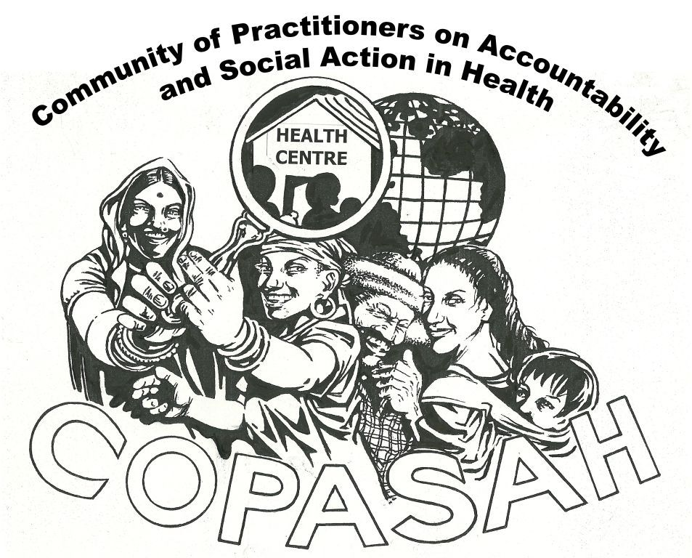
Community of Practitioners on Accountability and Social Action in Health (COPASAH) is a global network of practitioners with a common interest and passion for the field of community monitoring for accountability in health. COPASAH was set up by a group of practitioners who had come together for a meeting to share experiences at Johannesburg in July 2011 and currently has a steering committee of 8 members from Asia, Africa and Latin America. COPASAH places a strong emphasis on the role of civil society to promote access to equitable, quality and accountable health services. (Please visit www.copasah.net for more details)
South Asia region workshops were conducted in Mumbai in February, 2013 and September, 2013 to promote this perspective. Subsequent to these workshops quite a lot of conversations are happening among participants, and as a continuation to these COPASAH plans to organise three facilitated learning exchange visits in different parts of India. These visits are envisaged to facilitate peer learning and to enable strengthening of the practitioners’ forum.
The first of these visits is being organised at Naugarh, Chandauli district, Uttar Pradesh from December 17-19, 2013 with Gramya Sansthan (host organisation). This learning exchange visit seeks to provide practitioners an opportunity to visit a relevant organisation’s work and learn from and also provide feedback to the practitioners using a common set of principles. The visit is an extension of the principles and concepts discussed during the south Asian region COPASAH workshop in September, 2013.
Objective: To provide practitioners within the region an opportunity to visit a COPASAH member organisation and learn from their social accountability practice.
Host Organisation: The visit is being hosted by Gramya Sansthan, working in Chandauli, Sonbhadra and Varanasi districts of Uttar Pradesh on the issues of health rights of women, violence against women, child rights, labourers’ rights, right to food and rights of marginalized tribal. Gramya works on following programme areas:
  - Campaign for Dalit land right and resource control
  - Monitoring exclusion and violence against Dalits & Minorities
  - Campaign for right to food
  - Ensuring child rights with focus on girl child and child labour

Agenda: The aim of this learning exchange visit is to observe and learn from the community monitoring work being done by women representatives of the ‘Mahila Swasthya Adhikar Manch’ on the issue of maternal health rights. Discussions will also be held to reflect on the work being done by the organisation and how to apply this context in the participants’ own practice. The detailed session plan is as follows:

Date | Time | Session
17/12/2013  Tuesday | 11:00-12:30 | Round of introduction
 | 12:30-01:30 | Introduction to community monitoring and social accountability
 | 01:30-02:30 | Lunch Break
 | 02:30-03:30 | Evolving COPASAH’s perspectives on principles of social accountability
 | 03:30-04:00 | Tea Break
 | 04:00-05:30 | Presentation on:  - Gramya Sansthan’s history and work  - Organisational context (rationale on various issues the organisation is working on)  - Women’s health rights and accountability practice
 | 05:30-06:30 | Field visit plan and points for observation (field visit with community groups, health providers, documentation plans)
18/12/2013 Wednesday |  | Field visit to villages in Naugarh
19/12/2013  Thursday | 09:00-11:00 | Debriefing and interactive session
 | 11:00-11:30 | Tea break
 | 11:30-01:30 | Stories and experience sharing by leaders of Mahila Swasthya Adhikar Manch
 | 01:30-02:30 | Lunch break
 | 02:30-03:30 | Reflection and plans for implementing the learnings in participants’ own practice
 | 03:30-04:00 | Tea break
 | 04:00-05:00 | Report compilation by each participant

