Community Development Committees in urban slums

SAHAJ's initiative in Vadodara, Gujarat

Background

Data from the recent census (2011) shows that about 1/3rd of India's population lives in urban area and about 1/3rd of this number is estimated to live in urban slums. While a lot of attention has been focussed on rural health, especially post the National Rural Health Mission, urban areas have not received as much attention.

Society for Health Alternatives (SAHAJ) has been working in Vadodara, Gujarat's third largest city, since 1994. Since the early 2000s, SAHAJ has been working in several slums across the city to promote women's and girls' health. Their work has involved mobilizing the community around issues of health and offers some important lessons on achieving community participation in health in urban areas.

The context

Vadodara is the third largest city of Gujarat, a state in western India. Economic development of Gujarat has been seen as successful, however, the state lags behind some of the more developed states like Kerala and Tamil Nadu in its social development status.

In Vadodara. 20% of the population lives in more than 300 slums across the city. These slums are situated largely around the peripheries of the city and lack access to transport and other public facilities. Many of these slums are not legally recognized and the people living there face a constant threat of eviction. In addition, because they are unrecognized, they also lack several civic amenities like water supply, sanitation etc.

The communities living in these slums are migrants from other parts of Gujarat and also several other states. The men work as daily labourers or for wage work in the industries in the city while the women largely work as domestic help. Many of these migrants have been living together for almost a generation and therefore have a sense of community belonging even within the slum.

Objectives

The aims and objectives of this initiative that has been implemented over the last few years as part of several projects have been

To bring about sustainable social change in the marginalized communities living in bastis in Vadodara
  - by creating awareness among the community members on their health as well as civil rights,
  - by enhancing their capacities to interact with the local administration and fight for their rights to decent living through peaceful means to the extent possible.

One of the strategies towards achieving this objective has been to develop and strengthen Community Development Committees who can undertake community based advocacy for their health and civic entitlements. In addition, SAHAJ also does intensive work with adolescents and women in these communities – while some of this part of SAHAJ's work is mentioned here in relation to the work with Community Development Committees, they are not described in detail here.

Structure

SAHAJ's work with Community Development Committees extends to 17 slums/bastis across Vadodara. The work in some of these bastis is an organic evolution of previous years' work in them where SAHAJ has worked with adolescents and on maternal health. In addition, Community Development Committees have also been formed in some bastis where SAHAJ felt there was a need for these based on the population living there, presence of scheduled castes/religious minorities.

In each of these bastis, the SAHAJ team first interacts with community members explaining their work and objectives to community leaders and other members. Following this, a mass meeting is organized where again the objectives of SAHAJ's work with the community are shared. At this point, if the community members evince interest in participating in the process, SAHAJ takes the work forward. (There have been a few instances when SAHAJ has decided that it would not invest its resources in particular bastis because of lack of interest of community leaders and members).

At the mass meeting, community members are encouraged to bring up issues that they may be facing. After this, the possibility of forming a committee of interested persons from the community that could work towards solving these issues is raised. Certain ground rules about the committee are also discussed – every committee should have at least half its members as women and should be representative of the population of the basti. In addition, potential committee members are expected to work voluntarily for the benefit of the community, attend meetings regularly, have good communication skills and maintain peace and harmony in the community. Educational qualifications are not a criteria for membership. The role of the committee would be to represent people’s issues at various levels, be aware of different issues of the basti and find solutions for the same through regular meetings, disseminate information to the community, liaise between government officials and the people from bastis, monitor various government schemes and services available in the basti and mobilize the community for various events.

Following this discussion, community members present at the meeting elect/nominate members from the community to the committee. The membership to the committee remains open and flexible as the work expected is voluntary – as and when any person drops out or is unable to find time to give to the committee, new persons are elected to replace them.

Subsequently, SAHAJ has formed three sub committees out of each of these committees – one each on health, education and community development. This helps reduce the burden on the committee of working on several priority issues at the same time. It also helps widen the net of active members in the committee and helps them develop specialized skills for working in a particular focus area.

Thus, SAHAJ's work uses an autonomous space formed specifically for the purpose of community action. This space is representative of the community and is granted legitimacy by the community; however, it does not have any official sanction.

In addition, SAHAJ has formed a federation of these Committees – the Samanvay Samiti – in order to have a forum that will encourage cross learning and also take up issues that are common to several bastis across the city at a larger level.

Process

The first steps of the processes towards community action are described above along with a description of the structure – the introduction to the community and formation of committees. Subsequent to the formation of the committees, the following processes are implemented.

- Capacity building of committee members

Several sessions are held with committee members to build their capacity for community action. SAHAJ does not follow a systematic curriculum for this – the areas for capacity building are decided in consultation with the community based on the needs of the issue at hand. For example, when a committee wanted to take up the issue of corruption in the Public Distribution System (PDS) shop, sessions and materials on entitlements under PDS and Right to Food were prepared for use by the community. In addition, certain areas which are of use generally in advocacy and demand for entitlements, eg. Right to Information Act, are part of the capacity building sessions. These sessions are held periodically based on need. In addition, selected committee members are also taken on exposure visits to witness work done by other groups so they can be inspired from it and learn from it.

- Monthly meetings

The committees meet every month to discuss issues that are present in their bastis. Initially, these meetings are attended by staff of SAHAJ, but over a period of several months, SAHAJ moves to attending these meetings only when specific help and support is sought from the organization in issues that are beyond what the community can act on – for eg. to meet a senior bureaucrat / politician, contact the media etc. Thus, over a period of time, this process becomes owned by the local community making it sustainable.

- Action plan and implementation

The space of the monthly meeting is used to discuss and plan solutions for various issues. Issues are prioritized based on consultations among community members – very, often civic entitlements like ration cards, roads, drainage take precedence over issues directly related to health or health care. Some of these bastis also face constant danger of eviction and demolition. However, since these are the community's immediate survival needs, SAHAJ believes that they must be addressed and acted on before any meaningful discussion on health can take place.

Once the issues are identified, plans to solve these are made by the committee members with assignation of responsibility. Such plans could involve meeting the concerned authorities and giving an application, organizing demonstrations, filing Right to Information applications to get more details regarding entitlements. The actions are followed up in subsequent meetings and further plans made based on earlier results.

In many cases, because of the nature of the issues taken up, action needs to be long drawn out. Many committees have engaged with specific issues over two to three years highlighting the strength and sustainability of the process. In some instances, committee members have also planned data collection and regular activities like monitoring, as detailed in the case studies below.

At the beginning. SAHAJ's programme did not have a ready made tools to be used by the community to monitor services on a regular basis – any monitoring was taken up by the community's decision as and when need arose. Over time, and learning from a field visit to the Community Based Monitoring and Planning programme in Maharshtra, SAHAJ has evolved monitoring tools for Anganwadis, and the PDS.

SAHAJ also believes that its role in any action planned is only facilitatory – even where higher authorities have to be met to resolve a particular issue, SAHAJ puts the community in contact with them to directly interact. Limiting their role to facilitating, SAHAJ believes, empowers the community and makes the process sustainable for the community to take forward even without SAHAJ's support in the future. Also, since the community is involved directly in any action, they have realistic expectations from any actions planned and do not end up being frustrated with long drawn out struggles.

Outcomes

- Local communities coming together for local community action for local issues in urban area.
- Priority setting by communities resulting in a wide range of issues being taken up resulting in a very wide definition of health, thus work on broader determinants of health.

Learnings

- Urban communities have unique and specific challenges – civic amenities and determinants of health assume a crucial role in achieving health for all.
- Contrary to generally held views about urban areas, it is possible to organize urban communities around specific issues that affect all of them.
- It is important to address community's immediate priorities like shelter and sanitation before any work on issues like education and health can begin. In urban areas, health care is not so much an issue as determinants of health are.
- Issues addressed have to go across and beyond health sector and not just health care.
- Knowledge and awareness regarding entitlements can be a major trigger for change.
- Flexibility in the membership of committees leads to the development of a larger pool of leadership resource as people who have dropped out of committees also continue to play a leadership role in the community whenever the need arises.
- Effective and strategic engagement with the media can help support people's action.

Challenges

In this case, the NGO has played a facilitatory role by organizing the community, training them, providing support, facilitating direct contact with authorities. In the event of up scaling this to entire urban communities, SAHAJ team had a few suggestions.
  - Present ward committees do not reach upto the grassroots and have a heterogeneous representation of both slums and middle and upper class residents. It would be good to have basti level committees federated into core committees which then are represented on ward committees, so unique issues of such bastis have space to be raised.
  - The role played by the NGO here can be replicated by forming an Urban Health Resource Centre – with civil society representation or support from civil society, this could play a facilitatory role of supporting and building the capacities of basti level committees.

Monitoring the Anganwadi

In addition to forming Community Development Committees, SAHAJ has also helped form specific user groups in some bastis – Matru mandals or mothers' groups of pregnant and lactating women and mothers of young children are one such group of users of services from the Integrated Child Development Services (ICDS) programme.

In Gayatripura, a basti in Vadodara, women of the Matru Mandal have been engaging with the Anganwadi in their basti for over a year now. Earlier, the Anganwadi lacked a helper – thus, against the 30-35 children in the basti who should be going to the anganwadi, only 10-12 children would go everyday as their mothers who went out early morning as domestic helps could not drop them off at the Anganwadi at the scheduled time. The lack of a helper also affected the quality of food served to the children.

When the members of the Matru Mandal spoke to the Anganwadi worker about these issues, they got to understand that the lack of the helper was the root cause. They then sent out applications to the ICDS Department, and got the post of helper filled. Since then, more children have been attending the Anganwadi everyday.

The Matru Mandal members also decided that they had to ensure that the quality of the food their children ate everyday was up to the mark. Therefore, they have devised a system by which one of them in turn goes to the Anganwadi everyday before the food is served and tastes the food and checks its quality before it is served to the children.

Recent Events

Sanjay Nagar is a small basti with a population of around 500 people. When SAHAJ started working there in 2011, on Child Rights, the team realised that according to the population norms, the Mini Anganwadi Centre that the basti was entitled to, was not there. Four or five meetings with different groups of people living there apprised them of the services that they were entitled to. Groups of residents went to the relevant offices and made verbal requests for the Mini AWC to which there was no response. On Jan 28 2013 the first written application was sent to the Child development officer. When there was no response for six months, in August 2013, a second application was sent. This included a demand for a response as to why their application was not responded to. To this too, there was no reply. On May 23, 2014 the basti leaders filed an RTI. At once there was a flurry of activity – the officers visited the basti. There was a survey done. This revealed that there were not sufficient children between the ages of three and six. And those that were there were registered in the AWC in the neighbouring basti. People said, yes, they may be registered but they do not get the services – that AWC is across the road, we go to work, how can these small children cross the busy road and attend the AWC? Since that day, the Anganwadi helper comes twice a day – she escorts the children to and from the AWC.

The local animator and the community women started visiting the AWC. They found that no Mamta Divas is organised. When questioned the AWW said no one has told me... so I won’t. The animator went back and talked with the basti members. In July 2014 they wrote an application for the conduct of the Mamta Divas in the AWC. In August they sent a second application. A signature campaign in both Sanjay Nagar and the neighbouring bastis was done. On September 7, 2014 finally the first Mamta Divas was organised.

Through persistent and collective efforts, Sanjay Nagar succeeded in getting their children access services of an AWC, arranged that hot meals be provided to the children and got the Mamta Divas started. There are still many issues - unclean room, no toilet for the children and so on – but the women are confident they will be able to handle these too.

Addressing corruption in the Public Distribution System

One of the first issues taken up by the Community Development Committee of Mujhmahuda basti was that of corruption in the Public Distribution System (PDS) shop of their basti. This issue was brought up repeatedly during committee meetings. In order to understand the issue in further detail, committee members, with the support of SAHAJ staff, undertook a small survey in the basti that revealed several shortcomings – the shop was opened for much fewer hours than recommended, adequate quantities of grains were not being distributed according to people's entitlements, grains were being charged a much higher price than stipulated and the shopkeeper was probably siphoning off goods to his private shop. In addition to the survey, committee members were supported by SAHAJ which held training sessions for them on PDS entitlements and also printed material towards this.

Equipped with knowledge regarding their entitlements and information on the existing situation in their basti, committee members decided to take action on the issue. Attempts to dialogue and reason with the shopkeeper proved futile. Committee members then photocopied ration cards of households that documented the irregularities and submitted them to the PDS department and also petitioned the deputy Collector. However, since no follow up action resulted, the committee organized a protest rally to the shop.

On the day of the rally, since the issue resulted in widespread resonance in the community, several hundreds of people joined in and marched to the PDS shop and protested against the irregularities. SAHAJ staff helped with focusing media coverage on the event. The rally and the associated media coverage gained the attention of concerned authorities who temporarily suspended the license of the shopkeeper for a couple of months.

Following this, a committee member was chosen by the community to temporarily receive, store and distribute stocks with the help of the PDS department till the issue could be sorted out. Committee members also faced threats from the shopkeeper, but remained unfazed and in fact lodged formal complaints against the threats.

Subsequently, the same shopkeeper has been re-awarded the license due to his political connections – however, people now receive their entitlements since they are able to question him and monitor what they receive.

According to committee members, this successful action against corruption greatly energized the committee members. It also raised their standing and support in the community with more members opting to join the committee after this campaign.

Recent Events – last six months
We developed a monitoring tool and the Committee members started filling it up in their areas. Through discussion sit emerged that the quality had really deteriorated so people stopped going to the PDS shop. All the bastis jointly drafted a common application to the Purvatha Adhiakri on August 8, 2014. The Peer Leaders whom SAHAJ is currently working with, collected 354 signatures from 11 bastis. And they collected samples of the bad wheat and went to meet the Purvatah Adhikari. From every basti two or three people joined the delegation. The previous day they gave a press note and Divya Bhaskar covered the issue. The officer was not present in his office, but the people presented their issues to his assistant. And also gave TV interviews in front of his office. The local channels that day carried the story. The government started inspection of the PDS shops and there is now some improvement in the quality.

How long will it last, we wonder?

Salmaben telling the TV channel how poor the quality of ration is.
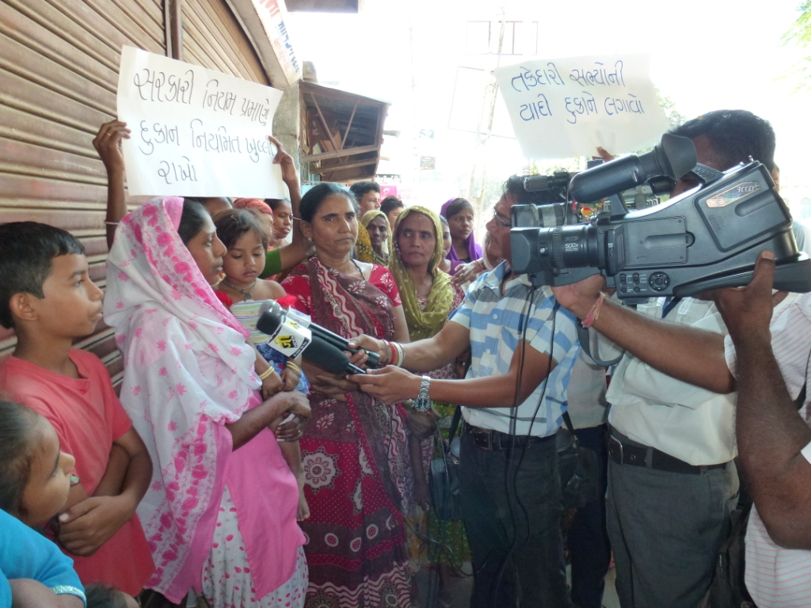

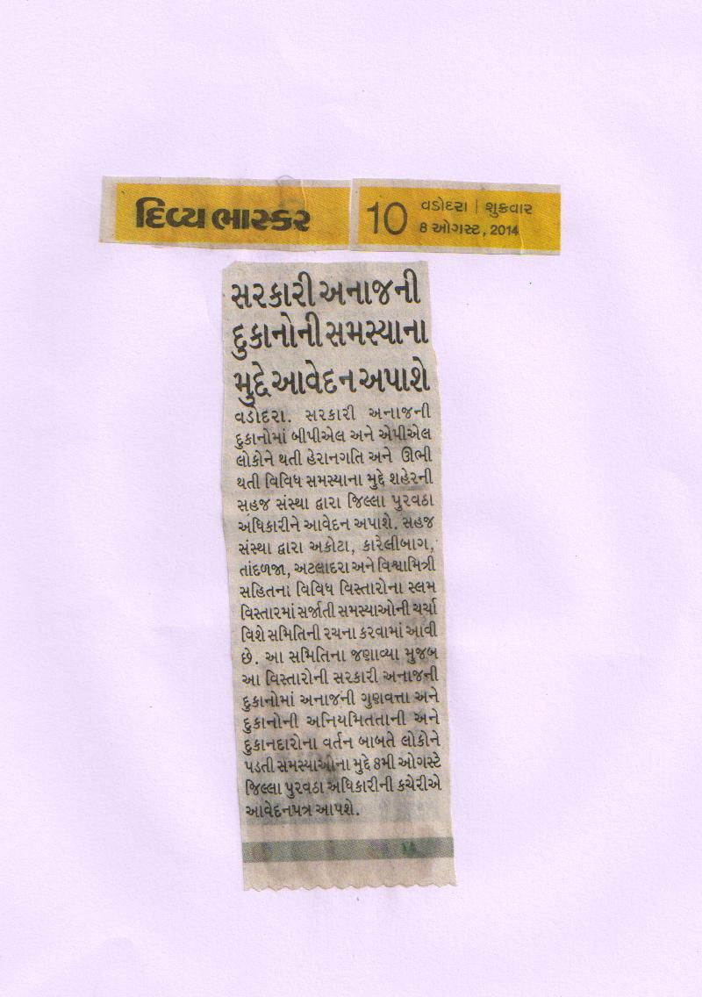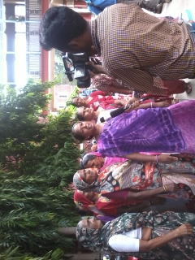

Meenaben from Gokul Nagar shared their experiences on bad quality of ration

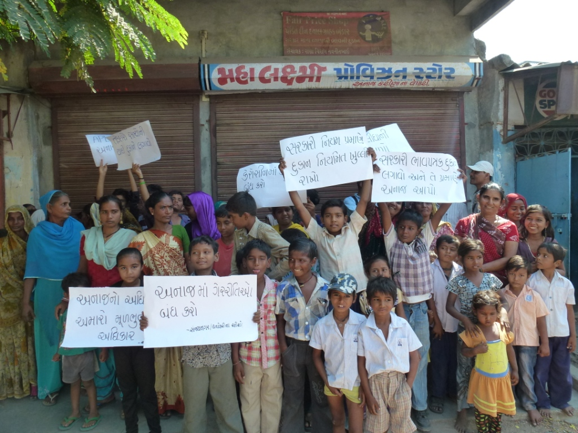

November 2011, Campaign on Right to Food

Action for school building

The Kavi Dayaram school in Mujhmahuda basti in Vadodara is more than 40 years old. The school functions from a single room in which four teachers handle classes from the first to the seventh standards. The school building is in poor condition with no functioning toilet for the students.

The Committee members in Mujhmahuda have taken up the issue of demanding a new school building for the past few years. They say they cannot afford to send their children to private schools. The lack of facilities also leads to the quality of education being very poor – a small survey they undertook with the help of SAHAJ showed them that children lack even basic literacy skills. They are concerned that this will lead their children to become “looteras” and “thieves.”

The committee members initially sent several applications to concerned authorities in the education department and also to their elected representatives. They even went and met the Education Minister. However, despite repeated assurances, nothing was done towards a new school building. Frustrated, in early 2010, committee members decided that they had to take some drastic action.

In January 2010, committee members organized other members from the community and marched to the school and locked the building saying they would not allow the school to function in such a dilapidated building. This resulted in a posse of police and the media arriving there. Even when faced with threats of lathi charge by the police, the committee members stuck to their demands. This resulted in the authorities promising to sanction a new building.

However, since nothing happened for over a year after that, committee members again went on a hunger strike to highlight their demands. After 4 days of the strike which was covered by the media, a new building was sanctioned and budget allocated. Committee members then organized a drawing competition for children to help them express what they wanted in a school. About 3 months ago, the construction of the new school building has finally begun.

Maternal Health
Subhashnagar, under the Vishwamitri overbridge, is a basti of abjectly poor people. In a basti women’s meeting, the SAHAJ Child Rights team enquired where they went for their maternal health needs. Women responded that the private sector was beyond them so they went to the public health facilities. They said that while the services are good, there are several issues that make public facilities unacceptable. A long discussion ensued.

One woman narrated that her younger sister had her delivery in SSG Hospital. The family believe that although a normal delivery was possible, she was made to have a Caesarian. The family members present saw the baby boy and her him cry. The family was thus shocked when the woman was handed a dead baby girl. The family raised a huge ruckus and only then they were handed over a live baby boy.

One of them spoke about labour room abuse. She said that she was made to lie down on the labour table and left unattended while the staff around her ate their breakfast and chatted away. It was freezing cold and when she requested the AC be turned down, no one heeded her. The relatives also intervened but there was no change in the behaviour of the staff. She was given ‘gaalis’ and also slapped when she was not able to bear down. Disgusted, the family took her home immediately after the delivery.

Women from another very marginalised basti Hanuman Nagar, brought out a new issue... Since SSG is attached to a medical college, they are subjected to medical students practicing vaginal examinations on them during the ANC visits. Because of this they have stopped going to the SSG for ANC checkups.

Because of these discussions and the issues highlighted by the women, the SAHAJ team has decided to monitor the quality of maternal health services using the pictorial tool Warli Madi being used in rural areas.

ICDS programme of the Government of India is a programme for early childhood development that aims to to improve the nutritional and health status of children in the age-group 0-6 years.

